COURSE 7

MODULE 2 - PROGRAMMING USING RSTUDIO

Using R can help you complete your analysis efficiently and effectively. In this part of the course, you’ll explore the fundamental concepts associated with R. You’ll learn about functions and variables for calculations and other programming. In addition, you'll discover R packages, which are collections of R functions, code and sample data that you’ll use in RStudio.

### Learning Objectives

* Describe the contents and components of the tidyverse package for R
* Describe the concept of packages in R programming language
* Describe the use of operators to complete calculations in the R programming language
* Describe the fundamental concepts associated with programming in R including functions, variables, data types, pipes, and vectors
* Install and load the tidyverse package
* Use the browseVignettes("packagename") function to read through vignettes of a loaded package
* Locate resources for help using R

BASIC PROGRAMMING CONCEPTS

[Programming using RStudio](https://www.coursera.org/learn/data-analysis-r/lecture/z5rIt/programming-using-rstudio)

We've given you a big-picture overview of R and RStudio. Now we'll turn our focus to the actual programming and coding you'll do using RStudio. I went pretty far in my career not knowing programming before it became clear, I needed to learn it. Getting to know R was such a valuable learning experience. It took some time, and I reached out to more-experienced R users with lots of questions. Eventually, it all came together for me. Being open to learning new skills is such an important part of your career. Now I'm able to help you learn some new skills too. I'll start by sharing the fundamentals of programming using R in RStudio. Earlier, we explained how R is like the engine of a car and RStudio is like the accelerator, steering wheel, and dashboard all in one. Getting to know fundamentals will help you keep your R car running smoothly. These fundamentals are both alike and different from the other analysis platforms you've come to know well: spreadsheets and SQL. Then we'll move on to coding in RStudio. We'll discuss the syntax for performing calculations and the standards and naming conventions for all code. We'll also explore the R tool known as a pipe, which you'll use to make a sequence of code easier to work with and read. Then we'll check out R packages. While these packages won't be delivered to your door, they are delivered by the R community. These packages contain reusable functions and more, and are usually built by users for users like yourself. We'll get to know a collection of packages called the Tidyverse. You'll learn how to install the Tidyverse so you can start using it in RStudio. We'll also work with some of the more popular Tidyverse packages like ggplot2 for visualization. You'll be able to carry over what you've learned about RStudio to the next part of the program, where you'll start working with data. As we explained earlier, for this program, we'll use the in-browser version of RStudio: RStudio Cloud. But RStudio is also available to be downloaded. So let's get going. See you soon.

[Programming fundamentals](https://www.coursera.org/learn/data-analysis-r/lecture/iMoxv/programming-fundamentals)

Anytime you're learning a new skill from cooking to driving to dancing, you should always start with the fundamentals. Programming with R is no different. To build this foundation, you'll get familiar with the basic concepts of R, including functions, comments, variables, data types, vectors, and pipes. Some of these terms might sound familiar. For example, we've come across functions in spreadsheets and SQL. As a quick refresher, functions are a body of reusable code used to perform specific tasks in R. Functions begin with function names like print or paste, and are usually followed by one or more arguments in parentheses. An argument is information that a function in R needs in order to run. Here's a simple function in action. Feel free to join in and try it yourself in RStudio using your cloud account. Check out the reading for more details on how to get started.

You can pause the video anytime you need to. We'll open RStudio Cloud to get started. We'll start our function in the console with the function name print. This function name will return whatever we include in the values in parentheses. We'll type an open parenthesis followed by a quotation mark. Both the close parenthesis and end quote automatically pop up because RStudio recognizes this syntax. Now we just have to add the text string. We'll type Coding in R.

Then we'll press enter.

Success! The code returns the words "Coding in R." If you want to find out more about the print function or any function, all you have to do is type a question mark, the function name, and a set of parentheses.

This returns a page in the Help window, which helps you learn more about the functions you're working with. Keep in mind that functions are case-sensitive, so typing Print with a Capital P brings back an error message.

Functions are great, but it can be pretty time-consuming to type out lots of values.

To save time, we can use variables to represent the values.

This lets us call out the values any time we need to with just the variable. Earlier, we learned about variables in SQL. A variable is a representation of a value in R that can be stored for use later during programming. Variables can also be called objects. As a data analyst, you'll find variables are very useful when programming. For example, if you want to filter a dataset, just assign a variable to the function you used to filter the data. That way, all you have to do is use that variable to filter the data later. When naming a variable in R, you can use a short phrase.

**A variable name should start with a letter and can also contain numbers and underscores.**

So the variable 5 penguin wouldn't work well because it starts with a number.

**Also just like functions, variable names are case-sensitive.**

Using all lowercase letters is good practice whenever possible. Now, before we get to coding a variable, let's add a comment. Comments are helpful when you want to describe or explain what's going on in your code. Use them as much as possible so that you and everyone can understand the reasoning behind it.

**Comments should be used to make an R script more readable. A comment shouldn't be treated as code, so we'll put a # in front of it**.

Then we'll add our comments. Here's an example of a variable.

Now let's go ahead with our example. It makes sense to use a variable name to connect to what the variable is representing. So we'll type the variable name first_variable.

Then after the variable name, we'll type a < sign, followed by a -.

This is the assignment operator. It assigns the value to the variable. It looks like an arrow, which makes sense, since it's pointing from the value to the variable. There are other assignment operators that work too, but it's always good to stick with just one type in your code. Next, we'll add the value that our variable will represent. We'll use the text, "This is my variable."

If we type the variable and hit Run, it will return the value that the variable represents. This is a very basic way of using a variable. You'll learn more ways of using variables in your code soon. For now, let's assign a variable to a different data type, numeric. We'll name this second_variable, and type our assignment operator. We'll give it the numeric value 12.5.

The Environment pane in the upper- right part of our work space now shows both of our variables and their values. There are other data types in R like logical, date, and date time. R has a few options for dealing with these data types. We'll explore them later. With functions, comments, variables, and data types, you've got a good foundation for working with R. We'll revisit these throughout this program, and show you how they're used in different ways during analysis.

Let's finish up with two more fundamental concepts, vectors and pipes.

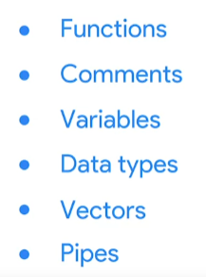

Simply put, **a vector is a group of data elements of the same type stored in a sequence in R**. You can make a vector using the combined function. In R this function is just the letter c followed by the values you want in your vector inside parentheses. All right, let's create a vector. Imagine this vector is for a measurement data that we need to analyze. We'll start our code with the variable vec_1 to assign to the vector.

Then we'll type c and the open parenthesis.Then we'll type our list of numbers separated by commas. We'll then close our parentheses and press enter.

This time when we type our variable and press enter, it returns our vector. We can use this vector anywhere in our analysis with only its variable name vec_1. The values in the vector will automatically be applied to our analysis. That brings us to the last of our fundamentals, pipes.

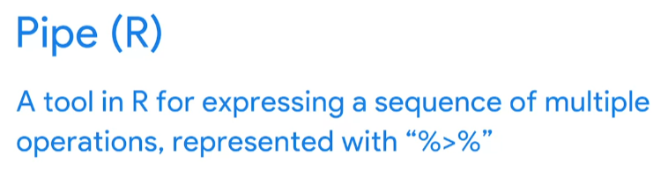

**A pipe is a tool in R for expressing a sequence of multiple operations.**

A pipe is represented by a % sign, followed by a > sign, and another % sign. It's used to apply the output of one function into another function. Pipes can make your code easier to read and understand. For example, this pipe filters and sorts the data. Later, we'll learn how each part of the pipe works. So there they are, the super six fundamentals: functions, comments, variables, data types, vectors, and pipes. They all work together as a foundation for using R. It's a lot to take in, so feel free to watch any of these videos again if you need a refresher. When you're ready, there's so much more to know about R and RStudio. So let's get to it.

[Vectors and lists in R](https://www.coursera.org/learn/data-analysis-r/supplement/7dRY6/vectors-and-lists-in-r)

In programming, a **data structure** is a format for organizing and storing data. Data structures are important to understand because you will work with them frequently when you use R for data analysis. The most common data structures in the R programming language include:

* Vectors
* Data frames
* Matrices
* Arrays

Think of a data structure like a house that contains your data.



This reading will focus on vectors. Later on, you’ll learn more about data frames, matrices, and arrays.

There are two types of vectors: **atomic vectors** and **lists**. Coming up, you’ll learn about the basic properties of atomic vectors and lists, and how to use R code to create them.

## **Atomic vectors**

First, we will go through the different types of atomic vectors. Then, you will learn how to use R code to create, identify, and name the vectors.

Earlier, you learned that a **vector** is a group of data elements of the *same* type, stored in a sequence in R. You cannot have a vector that contains both logicals and numerics.

There are six primary types of atomic vectors: logical, integer, double, character (which contains strings), complex, and raw. The last two–complex and raw–aren’t as common in data analysis, so we will focus on the first four. Together, integer and double vectors are known as numeric vectors because they both contain numbers. This table summarizes the four primary types:

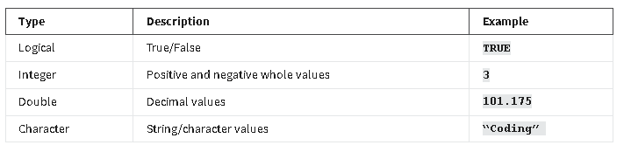

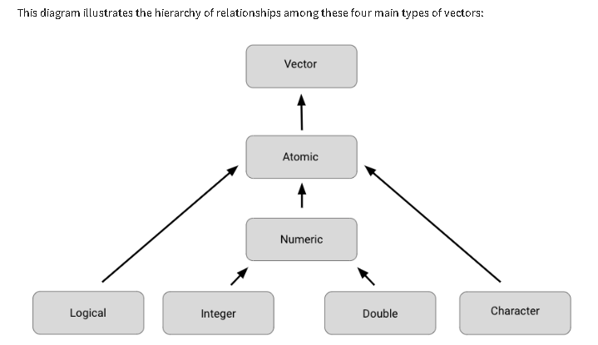

### **Creating vectors**

One way to create a vector is by using the **c()** function (called the “combine” function). The c() function in R combines multiple values into a vector. In R, this function is just the letter “c” followed by the values you want in your vector inside the parentheses, separated by a comma: c(x, y, z, …).

For example, you can use the c() function to store numeric data in a vector.

**c(2.5, 48.5, 101.5)**

To create a vector of integers using the c() function, you must place the letter "L" directly after each number.

**c(1L, 5L, 15L)**

You can also create a vector containing characters or logicals.

**c(“Sara” , “Lisa” , “Anna”)**

**c(TRUE, FALSE, TRUE)**

### **Determining the properties of vectors**

Every vector you create will have two key properties: type and length.

You can determine what type of vector you are working with by using the **typeof()** function. Place the code for the vector inside the parentheses of the function. When you run the function, R will tell you the type. For example:

**typeof(c(“a” , “b”))**

**#> [1] "character"**

Notice that the output of the typeof function in this example is **“character”**. Similarly, if you use the typeof function on a vector with integer values, then the output will include **“integer”** instead:

**typeof(c(1L , 3L))**

**#> [1] "integer"**

You can determine the length of an existing vector–meaning the number of elements it contains–by using the **length()** function. In this example, we use an assignment operator to assign the vector to the variable *x*. Then, we apply the length() function to the variable. When we run the function, R tells us the length is **3**.

**x <- c(33.5, 57.75, 120.05)**

**length(x)**

**#> [1] 3**

You can also check if a vector is a specific type by using an **is** function: **is.logical(), is.double(), is.integer(), is.character()**. In this example, R returns a value of **TRUE** because the vector contains integers.

**x <- c(2L, 5L, 11L)**

**is.integer(x)**

**#> [1] TRUE**

In this example, R returns a value of **FALSE** because the vector does *not* contain characters, rather it contains logicals.

**y <- c(TRUE, TRUE, FALSE)**

**is.character(y)**

**#> [1] FALSE**

### **Naming vectors**

All types of vectors can be named. Names are useful for writing readable code and describing objects in R. You can name the elements of a vector with the **names()** function. As an example, let’s assign the variable x to a new vector with three elements.

**x <- c(1, 3, 5)**

You can use the names() function to assign a different name to each element of the vector.

**names(x) <- c("a", "b", "c")**

Now, when you run the code, R shows that the first element of the vector is named **a**, the second **b**, and the third **c**.

**x**

**#> a b c**

**#> 1 3 5**

Remember that an atomic vector can only contain elements of the same type. If you want to store elements of different types in the same data structure, you can use a list.

## **Creating lists**

**Lists** are different from atomic vectors because their elements can be of any type—like dates, data frames, vectors, matrices, and more. Lists can even contain other lists.

You can create a list with the **list()** function. Similar to the c() function, the list() function is just **list** followed by the values you want in your list inside parentheses: **list(x, y, z, …)**. In this example, we create a list that contains four different kinds of elements: character (**"a"**), integer (**1L**), double (**1.5**), and logical (**TRUE**).

**list("a", 1L, 1.5, TRUE)**

Like we already mentioned, lists can contain other lists. If you want, you can even store a list inside a list inside a list—and so on.

**list(list(list(1 , 3, 5)))**

### **Determining the structure of lists**

If you want to find out what types of elements a list contains, you can use the **str()** function. To do so, place the code for the list inside the parentheses of the function. When you run the function, R will display the data structure of the list by describing its elements and their types.

Let’s apply the str() function to our first example of a list.

**str(list("a", 1L, 1.5, TRUE))**

We run the function, then R tells us that the list contains four elements, and that the elements consist of four different types: character (**chr**), integer (**int**), number (**num**), and logical (**logi**).

**#> List of 4**

**#> $ : chr "a"**

**#> $ : int 1**

**#> $ : num 1.5**

**#> $ : logi TRUE**

Let’s use the str() function to discover the structure of our second example. First, let’s assign the list to the variable *z* to make it easier to input in the str() function.

**z <- list(list(list(1 , 3, 5)))**

Let’s run the function.

**str(z)**

**#> List of 1**

**#> $ :List of 1**

**#> ..$ :List of 3**

**#> .. ..$ : num 1**

**#> .. ..$ : num 3**

**#> .. ..$ : num 5**

The indentation of the **$** symbols reflect the nested structure of this list. Here, there are three levels (so there is a list within a list within a list).

### **Naming lists**

Lists, like vectors, can be named. You can name the elements of a list when you first create it with the list() function:

**list('Chicago' = 1, 'New York' = 2, 'Los Angeles' = 3)**

**$`Chicago`**

**[1] 1**

**$`New York`**

**[1] 2**

**$`Los Angeles`**

**[1] 3**

## **Additional resource**

To learn more about vectors and lists, check out [R for Data Science, Chapter 20: Vectors](https://r4ds.had.co.nz/vectors.html#vectors). R for Data Science is a classic resource for learning how to use R for data science and data analysis. It covers everything from cleaning to visualizing to communicating your data. If you want to get more details about the topic of vectors and lists, this chapter is a great place to start.

[Dates and times in R](https://www.coursera.org/learn/data-analysis-r/supplement/g0l4l/dates-and-times-in-r)

In this reading, you will learn how to work with dates and times in R using the **lubridate** package. Coming up, you will use tools in the lubridate package to convert different types of data in R into date and date-time formats.

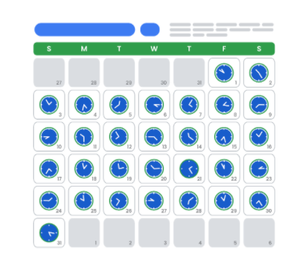

## **Loading tidyverse and lubridate packages**

Before you get started working with dates and times, you should load both **tidyverse** and **lubridate**. Lubridate is part of tidyverse.

First, open RStudio.

If you haven't already installed tidyverse, you can use the **install.packages()** function to do so:

* **install.packages("tidyverse")**

Next, load the tidyverse and lubridate packages using the **library()** function. First, load the core tidyverse to make it available in your current R session:

* **library(tidyverse)**

Then, load the lubridate package:

* **library(lubridate)**

Now you’re ready to be introduced to the tools in the lubridate package.

## **Working with dates and times**

This section covers the data types for dates and times in R and how to convert strings to date-time formats.

### **Types**

In R, there are three types of data that refer to an instant in time:

* A date **("2016-08-16")**
* A time within a day **(“20:11:59 UTC")**
* And a date-time. This is a date plus a time **("2018-03-31 18:15:48 UTC")**

The time is given in UTC, which stands for Universal Time Coordinated, more commonly called Universal Coordinated Time. This is the primary standard by which the world regulates clocks and time.

For example, to get the current date you can run the **today()** function. The date appears as year, month, and day.

**today()**

**#> [1] "2021-01-20"**

To get the current date-time you can run the **now()** function. Note that the time appears to the nearest second.

**now()**

**#> [1] "2021-01-20 16:25:05 UTC"**

When working with R, there are three ways you are likely to create date-time formats:

* From a string
* From an individual date
* From an existing date/time object

R creates dates in the standard yyyy-mm-dd format by default.

Let's go over each.

### **Converting from strings**

Date/time data often comes as strings. You can convert strings into dates and date-times using the tools provided by lubridate. These tools automatically work out the date/time format. First, identify the order in which the year, month, and day appear in your dates. Then, arrange the letters *y*, *m*, and *d* in the same order. That gives you the name of the lubridate function that will parse your date. For example, for the date *2021-01-20,* you use the order *ymd*:

**ymd("2021-01-20")**

When you run the function, R returns the date in yyyy-mm-dd format.

**#> [1] "2021-01-20"**

It works the same way for any order. For example, month, day, and year. R still returns the date in yyyy-mm-dd format.

**mdy("January 20th, 2021")**

**#> [1] "2021-01-20"**

Or, day, month, and year. R still returns the date in yyyy-mm-dd format.

**dmy("20-Jan-2021")**

**#> [1] "2021-01-20"**

These functions also take unquoted numbers and convert them into the yyyy-mm-dd format.

**ymd(20210120)**

**#> [1] "2021-01-20"**

### **Creating date-time components**

The ymd() function and its variations create dates. To create a date-time from a date*,* add an underscore and one or more of the letters *h*, *m*, and s (hours, minutes, seconds) to the name of the function:

**ymd_hms("2021-01-20 20:11:59")**

**#> [1] "2021-01-20 20:11:59 UTC"**

**mdy_hm("01/20/2021 08:01")**

**#> [1] "2021-01-20 08:01:00 UTC"**

### **Optional: Switching between existing date-time objects**

Finally, you might want to switch between a date-time and a date.

You can use the function **as_date()** to convert a date-time to a date. For example, put the current date-time—now()—in the parentheses of the function.

**as_date(now())**

**#> [1] "2021-01-20"**

## **Additional resources**

To learn more about working with dates and times in R, check out the following resources:

* [lubridate.tidyverse](https://lubridate.tidyverse.org/index.html): This is the “lubridate” entry from the official tidyverse documentation, which offers a comprehensive reference guide to the various tidyverse packages. Check out this link for an overview of key concepts and functions.
* [Dates and times with lubridate: Cheat Sheet](https://rawgit.com/rstudio/cheatsheets/master/lubridate.pdf): This “cheat sheet” gives you a detailed map of all the different things you can do with the lubridate package. You don’t need to know all of this information, but the cheat sheet is a useful reference for any questions you might have about working with dates and times in R.

[Other common data structures](https://www.coursera.org/learn/data-analysis-r/supplement/xEM9d/other-common-data-structures)

In this reading, you’ll continue exploring data structures through an introduction to data frames and matrices. You will learn about the basic properties of each structure, and simple ways to create them with R code. You’ll also briefly examine **files**, which are often used to access and store data and related information. The files and matrices sections of this reading are optional.

## **Data structures**

Recall that a data structure is like a house that contains your data, helping you to bring data elements together in a structured way that enables you to draw conclusions.



### **Data frames**

Data frames are the most common way of storing and analyzing data in R, so it’s important to understand what they are and how to create them. A **data frame** is a collection of columns containing data, similar to a spreadsheet or SQL table. Each column has a name that represents a variable and includes one observation per row. Data frames summarize data and organize it into a format that is easy to read and use.

For example, the data frame below shows the **diamonds** dataset, which is one of the preloaded datasets in R. Each column contains a single variable that is related to diamonds: carat, cut, color, clarity, depth, and so on. Each row represents a single observation.

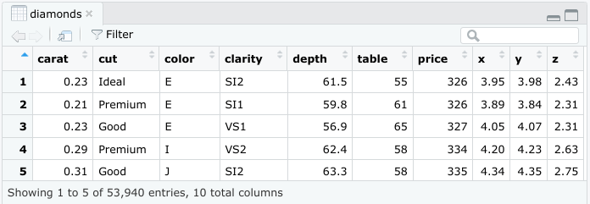

There are a few key things to keep in mind when working with data frames:

* Data frames can include many different types of data, including numeric, logical, or character.
* Data frames can have only one element in each cell.
* Each column should be named.
* Each column should consist of elements of the same data type.

You will learn more about data frames later on in the program, but this is a great starting point.

If you need to manually create a data frame in R, you can use the **data.frame()** function. The **data.frame()** function takes vectors as input. In the parentheses, enter the name of the column, followed by an equals sign, and then the vector you want to input for that column. In this example, the **x** column is a vector with elements 1, 2, 3, and the **y** column is a vector with elements 1.5, 5.5, 7.5. Run the following code to create the data frame.

data.frame(x = c(1, 2, 3) , y = c(1.5, 5.5, 7.5))

Run

Reset

When you run the code, R displays the data frame in ordered rows and columns.

Use the extract operator to extract a subset from a data frame. When you use this operator on a data frame, it takes two arguments: the row(s) and column(s) you’d like to extract, separated by a comma. As an example, name the data frame above z. Then, to extract the element from the second row and the first column, use the code **z[2,1]**, which returns a value of 2:

z <- data.frame(x = c(1, 2, 3) , y = c(1.5, 5.5, 7.5))

z[2,1]

Run

Reset

You’ll learn more about data frames later on in the course, but this is enough to get you started!

## **Optional: Files**

When you’re doing data analysis, you won’t usually create a data frame yourself. Instead, you’ll import data from another source, such as a .csv file, a relational database, or a software program. For this reason, it’s essential to be able to work with files in R. In this section, you’ll explore a few of the most useful functions for working with files, including commands to create, copy, and delete files in R.

### **Create a file**

Use the **file.create()** function to create a blank file. Place the name and the type of the file in the parentheses of the function. Your file types will usually be something like .txt, .docx, or .csv.

file.create("new_csv_file.csv")

If the file is successfully created when you run the function, R will return a value of **TRUE**. Otherwise, R will return a value of **FALSE**.

# [1] TRUE

file.create("new_csv_file.csv")

# code output:

### **Copy a file**

Copy a file with the **file.copy()** function. In the parentheses, add the name of the file to be copied. Then, enter a comma, and add the name of the destination folder that you want to copy the file to.

file.copy("new_text_file.txt", "destination_folder")

If you check the **Files** tab in RStudio, a copy of the file appears in the relevant folder:

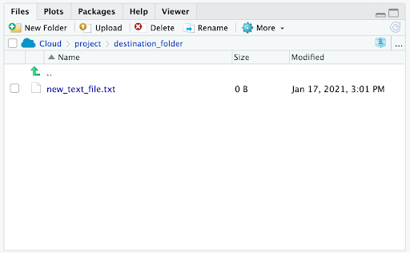

You can delete R files with the **unlink()** function. Enter the file’s name in the parentheses of the function.

unlink("some_.file.csv")

You’ll learn techniques for importing files into R later in this course.

## **Optional: Matrices**

A **matrix** is a two-dimensional collection of data elements. This means it has both rows and columns. By contrast, a vector is a one-dimensional sequence of data elements. But like vectors, matrices can only contain a single data type. For example, you can’t have both logicals and numerics in a matrix.

To create a matrix in R, you can use the **matrix()** function. The **matrix()** function has two main arguments that you enter in the parentheses. First, add a vector. The vector contains the values you want to place in the matrix. Next, add at least one matrix dimension. You can choose to specify the number of rows or the number of columns by using the code **nrow =** or **ncol =**.

For example, to create a 2x3 (two rows by three columns) matrix containing the values 3-8, enter a vector containing that series of numbers: **c(3:8)**. Then, enter a comma. Finally, enter **nrow = 2** to specify the number of rows. Run the code:

matrix(c(3:8), nrow = 2)

Run

Reset

R displays a matrix with three columns and two rows (typically referred to as a “2x3”) that contain the numeric values 3, 4, 5, 6, 7, 8. R places the first value (3) of the vector in the uppermost row, and the leftmost column of the matrix, and continues the sequence from left to right.

You can also choose to specify the number of columns (**ncol =** ) instead of the number of rows (**nrow =** ). Run the code:

matrix(c(3:8), ncol = 2)

Run

Reset

R infers the number of rows automatically.

Similar to data frames, you can extract an element from a matrix with the extract operator, **[]**.

## **Key takeaways**

As a data analyst, you’ll work with data frames often. Data frames in R are a collection of columns containing data, similar to a spreadsheet or SQL table. Data frames can contain data of different types, although each column must be of the same data type. By contrast, matrices are a collection of two-dimensional data elements that can only contain one data type. Usually, you’ll import data into R before you analyze it, so knowing how to use R to work with files is critical. You’ll learn techniques to import files later in this course, but you can also use R functions to create, copy, and delete files.

## **Resources for more information**

For more information on working with files in R, check out [R documentation: files](https://www.rdocumentation.org/packages/base/versions/3.6.2/topics/files). It’s a useful reference guide for functions in R code.

[Test your knowledge on programming concepts](https://www.coursera.org/learn/data-analysis-r/quiz/ZAvv4/test-your-knowledge-on-programming-concepts)

EXPLORE CODING IN R

[Operators and calculations](https://www.coursera.org/learn/data-analysis-r/lecture/quIEZ/operators-and-calculations)

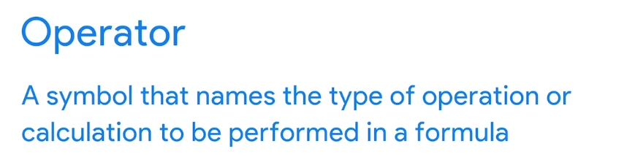

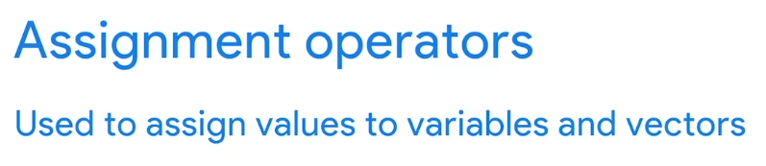



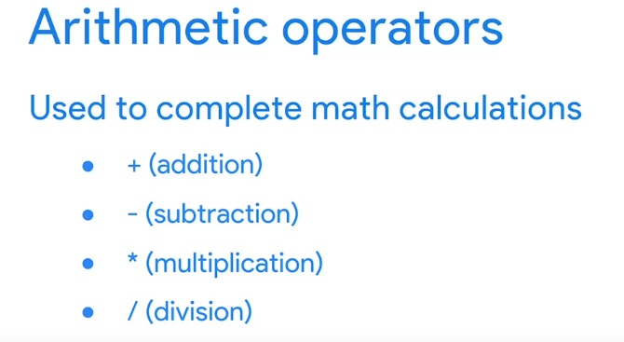

# our first calculations

quarter_1_sales <- 35657.98

quarter_2_sales <- 43810.55

midyear_sales <- quarter_1_sales + quarter_2_sales

**Note:** At closer glance, you will notice that the instructor highlighted the entire 4 lines of syntax together before running the code by pressing the "Run" button or pressing the hotkeys (**PC : CTRL + Enter** and **Mac: CMND + Enter**) .

As an alternative option, you may separately run each line of code one at a time after typing the syntax. Follow these steps in the script editor:

# our first calculations **(run the code)**

quarter_1_sales <- 35657.98 **(run the code)**

quarter_2_sales <- 43810.55 **(run the code)**

midyear_sales <- quarter_1_sales + quarter_2_sales **(run the code)**

Each variable will be committed to memory in the script editor before getting to the next line, so you won't receive an error when running the final line of code containing the *midyear_sales* variable.

[Logical operators and conditional statements](https://www.coursera.org/learn/data-analysis-r/supplement/I39VT/logical-operators-and-conditional-statements)

Earlier, you learned that an **operator** is a symbol that identifies the type of operation or calculation to be performed in a formula. In this reading, you will learn about the main types of logical operators and how they can be used to create conditional statements in R code.



## **Logical operators**

**Logical operators** return a logical data type such as TRUE or FALSE.

There are three primary types of logical operators:

* AND (sometimes represented as & or && in R)
* OR (sometimes represented as | or || in R)
* NOT (!)

Review the summarized logical operators below.

### **AND operator “&”**

* The AND operator takes two logical values. It returns **TRUE** only if both individual values are TRUE. This means that TRUE & TRUE evaluates to **TRUE**. However, FALSE & TRUE, TRUE & FALSE, and FALSE & FALSE all evaluate to **FALSE**.

If you run the corresponding code in R, you get the following results:

**> TRUE & TRUE**

**[1] TRUE**

**> TRUE & FALSE**

**[1] FALSE**

**> FALSE & TRUE**

**[1] FALSE**

**> FALSE & FALSE**

**[1] FALSE**

You can illustrate this using the results of our comparisons. Imagine you create a variable x that is equal to 10.

**x <- 10**

To check if x is greater than 3 but less than 12, you can use x > 3 and x < 12 as the values of an “AND” expression.

**x > 3 & x < 12**

When you run the function, R returns the result TRUE.

**[1] TRUE**

The first part, **x > 3** will evaluate to **TRUE** since 10 is greater than 3. The second part, **x < 12** will also evaluate to **TRUE** since 10 is less than 12. So, since both values are TRUE, the result of the AND expression is **TRUE**. The number 10 lies between the numbers 3 and 12.

However, if you make x equal to 20, the expression **x > 3 & x < 12** will return a different result.

**x <- 20**

**x > 3 & x < 12**

**[1] FALSE**

* Although **x > 3** is **TRUE** (20 > 3), **x < 12** is **FALSE** (20 < 12). If one part of an AND expression is FALSE, the entire expression is FALSE (TRUE & FALSE = FALSE). So, R returns the result **FALSE**.

### **OR operator “|”**

* The OR operator (|) works in a similar way to the AND operator (&). The main difference is that at least one of the values of the OR operation must be TRUE for the entire OR operation to evaluate to **TRUE**. This means that TRUE | TRUE, TRUE | FALSE, and FALSE | TRUE all evaluate to **TRUE**. When both values are FALSE, the result is **FALSE**.

If you write out the code, you get the following results:

**> TRUE | TRUE**

**[1] TRUE**

**> TRUE | FALSE**

**[1] TRUE**

**> FALSE | TRUE**

**[1] TRUE**

**> FALSE | FALSE**

**[1] FALSE**

For example, suppose you create a variable y equal to 7. To check if y is less than 8 or greater than 16, you can use the following expression:

**y <- 7**

**y < 8 | y > 16**

The comparison result is TRUE (7 is less than 8) | FALSE (7 is not greater than 16). Since only one value of an OR expression needs to be TRUE for the entire expression to be TRUE, R returns a result of TRUE.

**[1] TRUE**

Now, suppose y is 12. The expression y < 8 | y > 16 now evaluates to FALSE (12 < 8) | FALSE (12 > 16). Both comparisons are FALSE, so the result is **FALSE**.

**y <- 12**

**y < 8 | y > 16**

* **[1] FALSE**

### **NOT operator “!”**

* The NOT operator (!) simply negates the logical value it applies to. In other words, !TRUE evaluates to **FALSE**, and !FALSE evaluates to **TRUE**.

When you run the code, you get the following results:

**> !TRUE**

**[1] FALSE**

**> !FALSE**

**[1] TRUE**

Just like the OR and AND operators, you can use the NOT operator in combination with logical operators. Zero is considered FALSE and non-zero numbers are taken as TRUE. The NOT operator evaluates to the opposite logical value.

Let’s imagine you have a variable x that equals 2:

**x <- 2**

The NOT operation evaluates to FALSE because it takes the opposite logical value of a non-zero number (TRUE).

**> !x**

* **[1] FALSE**

-----------------

Let’s check out an example of how you might use logical operators to analyze data. Imagine you are working with the *airquality* dataset that is preloaded in RStudio. It contains data on daily air quality measurements in New York from May to September of 1973.

The data frame has six columns: *Ozone* (the ozone measurement), *Solar.R* (the solar measurement), *Wind* (the wind measurement), *Temp* (the temperature in Fahrenheit), and the *Month* and *Day* of these measurements (each row represents a specific month and day combination).

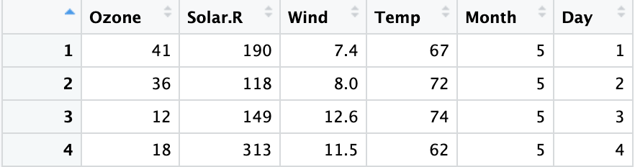

### **AND example**

Imagine you want to specify rows that are extremely sunny and windy, which you define as having a *Solar* measurement of over 150 anda *Wind* measurement of over 10.

In R, you can express this logical statement as **Solar.R > 150 & Wind > 10**.

Only the rows where *both* of these conditions are true fulfill the criteria:

Image of a single row of the “airquality” dataset in the RStudio data viewer.

## **OR example**

Next, imagine you want to specify rows where it’s extremely sunny or it’s extremely windy, which you define as having a *Solar* measurement of over 150 or a *Wind* measurement of over 10.

In R, you can express this logical statement as **Solar.R > 150 | Wind > 10**.

All the rows where *either* of these conditions are true fulfill the criteria:

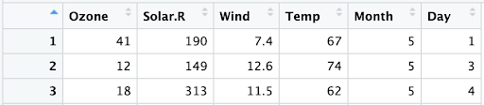

## **NOT example**

Now, imagine you just want to focus on the weather measurements for days that aren't the first day of the month.

In R, you can express this logical statement as **Day != 1**.

The rows where this condition is true fulfill the criteria:

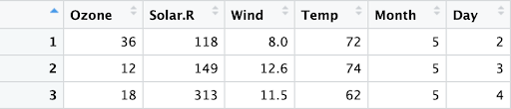

Finally, imagine you want to focus on scenarios that aren't extremely sunny and not extremely windy, based on your previous definitions of extremely sunny and extremely windy. In other words, the following statement should not be true: either a *Solar* measurement greater than 150 or a *Wind* measurement greater than 10.

Notice that this statement is the opposite of the OR statement used above. To express this statement in R, you can put an exclamation point (!) in front of the previous OR statement: **!(Solar.R > 150 | Wind > 10)**. R will apply the NOT operator to everything within the parentheses.

In this case, only one row fulfills the criteria:

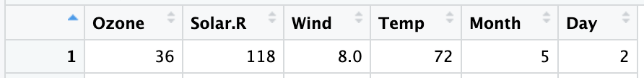

----------------------------------------------------------------------------------------------------------------------------------------

## **Optional: Conditional statements**

A **conditional statement** is a declaration that if a certain condition holds, then a certain event must take place. For example, “*If* the temperature is above freezing, *then* I will go outside for a walk.” If the first condition is true (the temperature is above freezing), then the second condition will occur (I will go for a walk). Conditional statements in R code have a similar logic.

Let’s discuss how to create conditional statements in R using three related statements:

* **if() / else() / else if()**

### **if statement**

The **if** statement sets a condition, and if the condition evaluates to **TRUE**, the R code associated with the if statement is executed.

In R, you place the code for the condition inside the parentheses of the if statement. The code that has to be executed if the condition is TRUE follows in curly braces (**expr**). Note that in this case, the second curly brace is placed on its own line of code and identifies the end of the code that you want to execute.

**if (condition) {**

**expr**

**}**

For example, let’s create a variable *x* equal to 4.

**x <- 4**

Next, let’s create a conditional statement: if *x* is greater than 0, then R will print out the string **“x is a positive number".**

**if (x > 0) {**

**print("x is a positive number")**

**}**

Since x = 4, the condition is true (4 > 0). Therefore, when you run the code, R prints out the string **“x is a positive number"**.

**[1] "x is a positive number"**

But if you change x to a negative number, like -4, then the condition will be FALSE (-4 > 0). If you run the code, R will not execute the print statement. Instead, a blank line will appear as the result.

### **else statement**

The **else** statement is used in combination with an if statement. This is how the code is structured in R:

**if (condition) {**

**expr1**

**} else {**

**expr2**

**}**

The code associated with the else statement gets executed whenever the condition of the if statement is *not* TRUE. In other words, if the condition is TRUE, then R will execute the code in the if statement (*expr1*); if the condition is *not* TRUE, then R will execute the code in the else statement (*expr2*).

Let’s try an example. First, create a variable *x* equal to 7.

**x <- 7**

Next, let’s set up the following conditions:

* If x is greater than 0, R will print **“x is a positive number”**.
* If x is less than or equal to 0, R will print **“x is either a negative number or zero”**.

In our code, the first condition (x > 0) will be part of the if statement. The second condition of x less than or equal to 0 is implied in the else statement. If x > 0, then R will print **“x is a positive number”**. Otherwise, R will print **“x is either a negative number or zero”**.

**x <- 7**

**if (x > 0) {**

**print ("x is a positive number")**

**} else {**

**print ("x is either a negative number or zero")**

**}**

Since 7 is greater than 0, the condition of the if statement is true. So, when you run the code, R prints out **“x is a positive number”**.

**[1] "x is a positive number"**

But if you make x equal to -7, the condition of the if statement is *not* true (-7 is not greater than 0). Therefore, R will execute the code in the else statement. When you run the code, R prints out **“x is either a negative number or zero”**.

**x <- -7**

**if (x > 0) {**

**print("x is a positive number")**

**} else {**

**print ("x is either a negative number or zero")**

**}**

**[1] "x is either a negative number or zero"**

### **else if statement**

In some cases, you might want to customize your conditional statement even further by adding the **else if** statement. The else if statement comes in between the if statement and the else statement. This is the code structure:

**if (condition1) {**

**expr1**

**} else if (condition2) {**

**expr2**

**} else {**

**expr3**

**}**

If the if condition (*condition1*) is met, then R executes the code in the first expression (*expr1*). If the if condition is not met, and the else if condition (*condition2*) is met, then R executes the code in the second expression (*expr2*). If neither of the two conditions are met, R executes the code in the third expression (*expr3*).

In our previous example, using only the if and else statements, R can only print **“x is either a negative number or zero”** if x equals 0 or x is less than zero. Imagine you want R to print the string **“x is zero”** if x equals 0. You need to add another condition using the else if statement.

Let’s try an example. First, create a variable *x* equal to negative 1 (“-1”), and *run the code* to save the variable to memory.

**x <- -1**

Now, you want to set up the following conditions:

* If x is less than 0, print **“x is a negative number”**
* If x equals 0, print **“x is zero”**
* Otherwise, print **“x is a positive number”**

In the code, the first condition will be part of the if statement, the second condition will be part of the else if statement, and the third condition will be part of the else statement. If x < 0, then R will print **“x is a negative number”.** If x = 0, then R will print **“x is zero”**. Otherwise, R will print **“x is a positive number”**.

**x <- -1**

**# run the code**

**if (x < 0) {**

**print("x is a negative number")**

**} else if (x == 0) {**

**print("x is zero")**

**} else {**

**print("x is a positive number")**

**}**

Run the code. Since -1 is less than 0, the condition for the if statement evaluates to **TRUE**, and R prints **“x is a negative number”**.

**[1] "x is a negative number"**

If you make x equal to 0, R will first check the if condition **(x < 0)**, and determine that it is FALSE. Then, R will evaluate the else if condition. This condition, **x==0**, is TRUE. So, in this case, R prints **“x is zero”**.

If you make x equal to 1, both the if condition and the else if condition evaluate to **FALSE**. So, R will execute the else statement and print **“x is a positive number”**.

As soon as R discovers a condition that evaluates to TRUE, R executes the corresponding code and ignores the rest.

## **Additional resource**

To learn more about logical operators and conditional statements, check out DataCamp's tutorial [Conditionals and Control Flow in R](https://www.datacamp.com/community/tutorials/conditionals-and-control-flow-in-r). DataCamp is a popular resource for people learning about computer programming. The tutorial is filled with useful examples of coding applications for logical operators and conditional statements (and relational operators), and offers a helpful overview of each topic and the connections between them.

[Guide: Keeping your code readable](https://www.coursera.org/learn/data-analysis-r/supplement/fQFvb/guide-keeping-your-code-readable)

[Hands-On Activity: R sandbox](https://www.coursera.org/learn/data-analysis-r/quiz/lJaOP/hands-on-activity-r-sandbox)

[Queries and programming](https://www.coursera.org/learn/data-analysis-r/discussionPrompt/LociE/queries-and-programming)

[Basic Concepts of R](https://www.coursera.org/learn/data-analysis-r/ungradedWidget/rr7Yj/basic-concepts-of-r)

[Test your knowledge on coding in R](https://www.coursera.org/learn/data-analysis-r/quiz/O9zRl/test-your-knowledge-on-coding-in-r)

LEARN ABOUT R PACKAGES

[The gift that keeps on giving](https://www.coursera.org/learn/data-analysis-r/lecture/2xqTb/the-gift-that-keeps-on-giving)

[Available R packages](https://www.coursera.org/learn/data-analysis-r/supplement/PvhrW/available-r-packages)

[Welcome to the tidyverse](https://www.coursera.org/learn/data-analysis-r/lecture/MbsrZ/welcome-to-the-tidyverse)

[Hands-On Activity: Installing and loading tidyverse](https://www.coursera.org/learn/data-analysis-r/quiz/CWrfL/hands-on-activity-installing-and-loading-tidyverse)

[Test your knowledge on R packages](https://www.coursera.org/learn/data-analysis-r/quiz/kjAEM/test-your-knowledge-on-r-packages)

EXPLORE THE TIDYVERSE

[More on the tidyverse](https://www.coursera.org/learn/data-analysis-r/lecture/oiFFN/more-on-the-tidyverse)

[Use pipes to nest code](https://www.coursera.org/learn/data-analysis-r/lecture/5AFvs/use-pipes-to-nest-code)

[R resources for more help](https://www.coursera.org/learn/data-analysis-r/supplement/aFF6V/r-resources-for-more-help)

[Connor: Coding tips](https://www.coursera.org/learn/data-analysis-r/lecture/DnANW/connor-coding-tips)

[Test your knowledge on the tidyverse](https://www.coursera.org/learn/data-analysis-r/quiz/9hVei/test-your-knowledge-on-the-tidyverse)

M2 CHALLENGE

[Glossary: Terms and definitions](https://www.coursera.org/learn/data-analysis-r/supplement/8yMUQ/glossary-terms-and-definitions)

[Module 2 challenge](https://www.coursera.org/learn/data-analysis-r/exam/XJNIH/module-2-challenge)